3dimensional jagged array
Eg: Array_3D_jagged
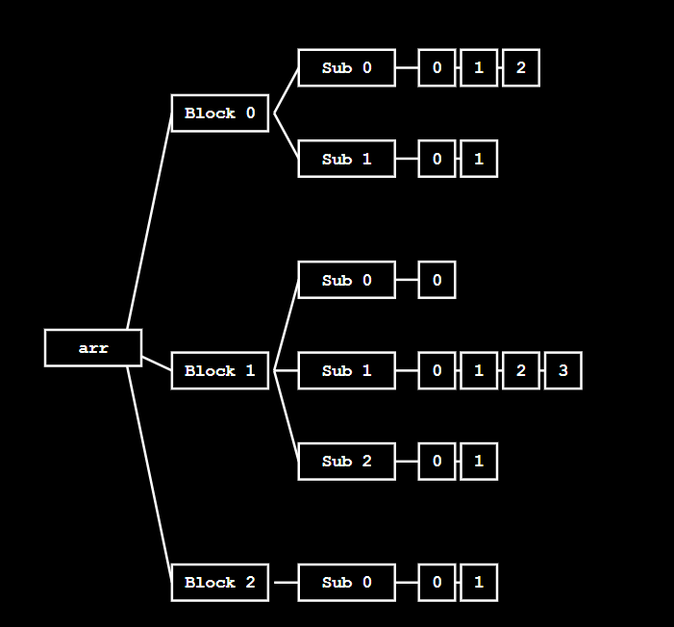

🔹 Given 3D Jagged Array (Target Structure)
We want the loops to finally create this exact structure:
int[][][] arr = {
{ {10, 11, 12}, {20, 21} },
{ {30}, {40, 41, 42, 43}, {50, 51} },
{ {60, 61} }
};

🔹 Meaning of This Structure
First dimension (outer) size = 3

arr[0] → 2 inner arrays
arr[1] → 3 inner arrays
arr[2] → 1 inner array

Inner sizes:
arr[0][0] → 3 elements
arr[0][1] → 2 elements

arr[1][0] → 1 element
arr[1][1] → 4 elements
arr[1][2] → 2 elements

arr[2][0] → 2 elements

🔹 Loops Under Discussion
for (int i = 0; i < colleges; i++) {

int classes = sc.nextInt();
arr[i] = new int[classes][];

for (int j = 0; j < classes; j++) {

int students = sc.nextInt();
arr[i][j] = new int[students];
}
}
So:
colleges = 3

🔸 Initial State (Before Loops)
arr → [ null , null , null ]

Memory now:
arr →
[
null,
null,
null
]

🔁 OUTER LOOP : Iteration – 0
int i = 0 ; i (0) < 3 → true

classes = 2
(because arr[0] has 2 inner arrays)
arr[0] = new int[2][]

Memory now:
arr →
[
[ null , null ],
null,
null
]

inner loop : iteration – 0
j = 0 ; j (0) < 2 → true

students = 3
(because arr[0][0] has 3 elements)
arr[0][0] = {10, 11, 12}

Memory now:
arr →
[
[
[ 10 , 11 , 12 ],
null
],
null,
null
]

inner loop : iteration – 1
j = 1 ; j (1) < 2 → true

students = 2
(because arr[0][1] has 2 elements)
arr[0][1] = {20, 21}

Memory now:
arr →
[
[
[ 10 , 11 , 12 ],
[ 20 , 21 ]
],
null,
null
]

inner loop : iteration – 2
j = 2 ; j (2) < 2 → false
➡️ inner loop condition failed
➡️ control comes to outer loop

🔁 OUTER LOOP : Iteration – 1
int i = 1 ; i (1) < 3 → true

classes = 3
(because arr[1] has 3 inner arrays)
arr[1] = new int[3][]

Memory now:
arr →
[
[
[ 10 , 11 , 12 ],
[ 20 , 21 ]
],
[ null , null , null ],
null
]

inner loop : iteration – 0
j = 0 ; j (0) < 3 → true

students = 1
(because arr[1][0] has 1 element)
arr[1][0] = {30}

Memory now:
arr →
[
[
[ 10 , 11 , 12 ],
[ 20 , 21 ]
],
[
[ 30 ],
null,
null
],
null
]

inner loop : iteration – 1
j = 1 ; j (1) < 3 → true

students = 4
(because arr[1][1] has 4 elements)
arr[1][1] = {40, 41, 42, 43}

Memory now:
arr →
[
[
[ 10 , 11 , 12 ],
[ 20 , 21 ]
],
[
[ 30 ],
[ 40 , 41 , 42 , 43 ],
null
],
null
]

inner loop : iteration – 2
j = 2 ; j (2) < 3 → true

students = 2
(because arr[1][2] has 2 elements)
arr[1][2] = {50, 51}

Memory now:
arr →
[
[
[ 10 , 11 , 12 ],
[ 20 , 21 ]
],
[
[ 30 ],
[ 40 , 41 , 42 , 43 ],
[ 50 , 51 ]
],
null
]

inner loop : iteration – 3
j = 3 ; j (3) < 3 → false
➡️ inner loop condition failed
➡️ control comes to outer loop

🔁 OUTER LOOP : Iteration – 2
int i = 2 ; i (2) < 3 → true

classes = 1
(because arr[2] has 1 inner array)
arr[2] = new int[1][]

Memory now:
arr →
[
[
[ 10 , 11 , 12 ],
[ 20 , 21 ]
],
[
[ 30 ],
[ 40 , 41 , 42 , 43 ],
[ 50 , 51 ]
],
[ null ]
]

inner loop : iteration – 0
j = 0 ; j (0) < 1 → true

students = 2
(because arr[2][0] has 2 elements)
arr[2][0] = {60, 61}

Memory now:
arr →
[
[
[ 10 , 11 , 12 ],
[ 20 , 21 ]
],
[
[ 30 ],
[ 40 , 41 , 42 , 43 ],
[ 50 , 51 ]
],
[
[ 60 , 61 ]
]
]

inner loop : iteration – 1
j = 1 ; j (1) < 1 → false
➡️ inner loop condition failed
➡️ control comes to outer loop

🔁 OUTER LOOP : Iteration – 3
int i = 3 ; i (3) < 3 → false
➡️ outer loop condition failed
➡️ outer loop ends

✅ FINAL MEMORY STATE (WITH ACTUAL VALUES)
arr →
[
[ [10,11,12], [20,21] ],
[ [30], [40,41,42,43], [50,51] ],
[ [60,61] ]
]

📌 Important Note (Very Important for Understanding)
In the above explanation, the numbers shown inside the array are only for understanding and visualization purpose.
Up to these two for loops, we are NOT storing actual values into the array.
These loops are used only to create the 3-dimensional jagged structure (first level, second level, and third level arrays).
The real values will be stored later using another separate set of for loops, which will be shown next.

🧠 One-Line Core Truth (Interview Friendly)
First set of loops creates the jagged array structure; a separate set of loops is required to store actual values.

for (int i = 0; i < arr.length; i++) {

// arr[i] represents one second-level group
for (int j = 0; j < arr[i].length; j++) {

// arr[i][j] represents one third-level array
for (int k = 0; k < arr[i][j].length; k++) {

/*
arr[i][j][k] access order:
- first select first-level reference
- then select second-level reference
- then store value at deepest level
*/
System.out.print(
"Enter marks for college " + i +
", class " + j +
", student " + k + ": ");

arr[i][j][k] = sc.nextInt();
}
}
}

🔸 Initial State (Before Value Insertion Loops)
Structure already exists, but values are not yet stored.

Memory now:
arr →
[
[ [ _ , _ , _ ], [ _ , _ ] ],
[ [ _ ], [ _ , _ , _ , _ ], [ _ , _ ] ],
[ [ _ , _ ] ]
]
(_ means empty / not assigned yet)

🔁 1️⃣ OUTERMOST LOOP

Step 1
i = 0 ; i (0) < 3 → true
➡️ control goes to middle loop

🔁 2️⃣ MIDDLE LOOP (for i = 0)

Step 2
j = 0 ; j (0) < 2 → true
➡️ control goes to inner loop

🔁 3️⃣ INNER LOOP (for i = 0, j = 0)

Step 3
k = 0 ; k (0) < 3 → true
arr[0][0][0] = 10

Memory now:
arr →
[
[ [ 10 , _ , _ ], [ _ , _ ] ],
[ [ _ ], [ _ , _ , _ , _ ], [ _ , _ ] ],
[ [ _ , _ ] ]
]

Step 4
k = 1 ; k (1) < 3 → true
arr[0][0][1] = 11

Memory now:
arr →
[
[ [ 10 , 11 , _ ], [ _ , _ ] ],
[ [ _ ], [ _ , _ , _ , _ ], [ _ , _ ] ],
[ [ _ , _ ] ]
]

Step 5
k = 2 ; k (2) < 3 → true
arr[0][0][2] = 12

Memory now:
arr →
[
[ [ 10 , 11 , 12 ], [ _ , _ ] ],
[ [ _ ], [ _ , _ , _ , _ ], [ _ , _ ] ],
[ [ _ , _ ] ]
]

Step 6
k = 3 ; k (3) < 3 → false
➡️ inner loop ends
➡️ control goes to middle loop

🔁 2️⃣ MIDDLE LOOP (for i = 0)

Step 7
j = 1 ; j (1) < 2 → true
➡️ control goes to inner loop

🔁 3️⃣ INNER LOOP (for i = 0, j = 1)

Step 8
k = 0 ; k (0) < 2 → true
arr[0][1][0] = 20

Memory now:
arr →
[
[ [ 10 , 11 , 12 ], [ 20 , _ ] ],
[ [ _ ], [ _ , _ , _ , _ ], [ _ , _ ] ],
[ [ _ , _ ] ]
]

Step 9
k = 1 ; k (1) < 2 → true
arr[0][1][1] = 21

Memory now:
arr →
[
[ [ 10 , 11 , 12 ], [ 20 , 21 ] ],
[ [ _ ], [ _ , _ , _ , _ ], [ _ , _ ] ],
[ [ _ , _ ] ]
]

Step 10
k = 2 ; k (2) < 2 → false
➡️ inner loop ends
➡️ control goes to middle loop

Step 11
j = 2 ; j (2) < 2 → false
➡️ middle loop ends
➡️ control goes to outer loop

🔁 1️⃣ OUTERMOST LOOP

Step 12
i = 1 ; i (1) < 3 → true
➡️ control goes to middle loop

🔁 2️⃣ MIDDLE LOOP (for i = 1)

Step 13
j = 0 ; j (0) < 3 → true
➡️ control goes to inner loop

🔁 3️⃣ INNER LOOP (for i = 1, j = 0)

Step 14
k = 0 ; k (0) < 1 → true
arr[1][0][0] = 30

Memory now:
arr →
[
[ [ 10 , 11 , 12 ], [ 20 , 21 ] ],
[ [ 30 ], [ _ , _ , _ , _ ], [ _ , _ ] ],
[ [ _ , _ ] ]
]

Step 15
k = 1 ; k (1) < 1 → false
➡️ inner loop ends
➡️ control goes to middle loop

🔁 2️⃣ MIDDLE LOOP (for i = 1)

Step 16
j = 1 ; j (1) < 3 → true
➡️ control goes to inner loop

🔁 3️⃣ INNER LOOP (for i = 1, j = 1)
arr[1][1][0] = 40
arr[1][1][1] = 41
arr[1][1][2] = 42
arr[1][1][3] = 43

Memory now:
arr →
[
[ [ 10 , 11 , 12 ], [ 20 , 21 ] ],
[ [ 30 ], [ 40 , 41 , 42 , 43 ], [ _ , _ ] ],
[ [ _ , _ ] ]
]

🔁 Continue (same flow)
arr[1][2][0] = 50
arr[1][2][1] = 51

Memory now:
arr →
[
[ [ 10 , 11 , 12 ], [ 20 , 21 ] ],
[ [ 30 ], [ 40 , 41 , 42 , 43 ], [ 50 , 51 ] ],
[ [ _ , _ ] ]
]

🔁 OUTERMOST LOOP (i = 2)
arr[2][0][0] = 60
arr[2][0][1] = 61

Memory now:
arr →
[
[ [ 10 , 11 , 12 ], [ 20 , 21 ] ],
[ [ 30 ], [ 40 , 41 , 42 , 43 ], [ 50 , 51 ] ],
[ [ 60 , 61 ] ]
]

✅ FINAL MEMORY STATE (After Value Insertion)
arr →
[
[ [10,11,12], [20,21] ],
[ [30], [40,41,42,43], [50,51] ],
[ [60,61] ]
]

